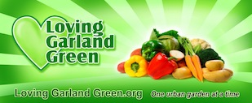
LATEST NEWS!

Our next scheduled meeting is Monday, October 27.

LATEST AGENDA
Visit us also on Twitter and Facebook!
https://twitter.com/LovingGarland
https://www.facebook.com/loving.garlandgreen

IRS Certification as a 501 (c)(3) Public Charity

Loving Garland Green is officially tax exempt from Federal Income Tax under section 501(c)(3) of the Internal Revenue Code. Contributions to our organization are deductible under section 170 of the Code. We are qualified to receive tax deductible bequests, devises, transfers or gifts under section 2055, 2106 or 2522 of the Code. It has been determined that we are a public charity. Our effective date of exemption is January 15, 2014.
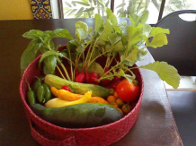

First Bounty from the Garland Community Garden: Jalapeno peppers, yellow squash, zucchini, radishes, yellow cherry tomatoes ,one large heirloom red tomato, and basil. This bounty was delivered to the Good Samaritans on June 14, 2014--two months and two days after we planted our garden on April 12, 2014.

Installation of the Garland Multicultural Commission Plot was a success!

We appreciate those who attended and extend a special thank you to the following individuals: Ed Moore for starting the ball rolling for this event. Kaushalya Siriwardanda who was the Garland Multicultural Commission (GMC) chair for this event; Nancy Seaberg, the Loving Garland Green chair for this event; Jennifer Nguyen, Chairperson for GMC; members of VietFace who televised the event; and to our Mayor Douglas Athas who took time out from his busy schedule to honor the importance of this event with his presence.
________________________
October is our Birthday Month!
We've come a long way from our first meeting on October 24, 2013. We had 11 people at that first meeting and today we have 22 members. We had no garden plots down at 4022 Naaman School Road on October 24. Today we have approximately 1,200 square feet of garden beds including our winding garden. We've had many bumps along the way, but like the bees, we've hung in there.
We installed our first garden bed on April 12, 2014. It was a square foot garden, size four feet by seven feet. Gene Rodgers built an Olla system for it.
Remember when, this was all there was?
