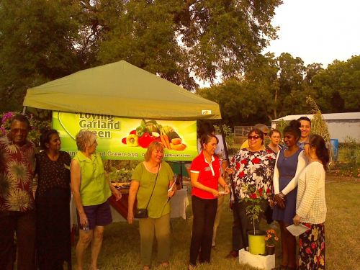
Left to Right: Ed Moore, Garland Community Multicultural Commission (GMC); Kaushalya Siriwardana, GMC Chair for the event; Marie Mathis, Member Loving Garland Green (LGG); Nancy Seaberg, LGG Chair for the event; Jennifer Nguyen, GMC Chair; Minerva Moreno, member of GMC; and other members of the Garland multicultural community.

October 8 - Installation of the Garland Multicultural Garden Plot
A little wisdom from two cultures:
"Attending to great things at small beginnings. . ." Verse 64 of Tao Te Ching
"Though your beginning was insignificant, Yet your end will increase greatly." Job 8:7
______________________________________
Historical footnote: It good to retrace steps leading to a successful event so that it can be repeated. This entire event was set in motion back in February or March when Ed Moore, then Chair of the Garland Community Multicultural Commission, attended a Loving Garland Green meeting to tell us about the Commission and to ask how they might get involved with us. The rest is history. As a result of Ed's first step, our organization is now aware of the multicultural commission and we've told others about this commission and its contributions to our community.. There are many ways in which the many cultures of our community contribute to our local food diversity and thus food security of our community. Thank you, Ed, for setting this all in motion.
_________________________________________
I don't know where Loving Garland Green is going as an organization, but I feel like we are going somewhere good--especially after last night. Our official installation of the Garland Multicultural Garden Plot was a warm, friendly and personal event that was well-attended by people representative of many cultures in our community. It was an informal event where guests paired up with various members of Loving Garland Green and toured areas of our Garland Community Garden. Charlie Bevilacqua, one of our board members, assisted guests who wanted cuttings of our citronella plant, red okra and loofah.
Jennifer Nguyen, Chair of the Garland Community Multicultural Commission, presented Loving Garland Green with seeds from plants that we don't normally see on the seed racks in our local stores--a reminder to visit our Asian markets here in Garland too. Malabar Spinach, Kohlrabi and Bitter Melon.
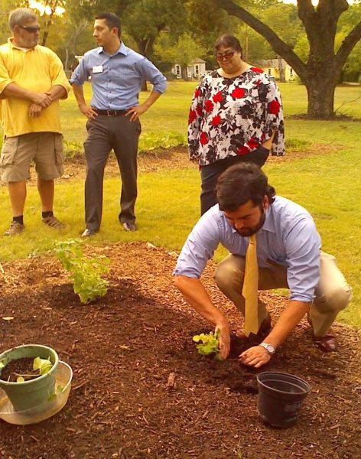
Ricardo Roca from the Garland Community Multicultural Commission installs a plant in the Garland Multicultural plot at our Garland Community Garden.
According to the Dallas Morning News, about 110,000 Vietnamese live in the Dallas area. Some of the most enthusiastic and prolific gardeners in our DFW area are members from our Asian community. This fact was evidenced by the attendees of this event. I would estimate that close to 50% of those who attended were of Asian heritage.
VietFace TV Texas recorded the event and took a tour of the garden with Nancy Seaberg, Loving Garland Green Chair for our part of this event.
We look forward to increasing the food diversity and thus the food security of our local community by helping to bring to the public the wealth of information from all our residents regarding edibles that can be grown here in Garland Texas.
Note: This event was also attended by Mayor Douglas Athas. We are so fortunate to have a mayor who supports the greening of our community. Thank you Mayor Doug!
_________________________________________
OUR GARLAND COMMUNITY MULTICULTURAL COMMISSION IS NOT LIMITED TO GARDENING.
They also host one of the most special events of the year here in Garland.
Be sure to mark your calendar for Saturday, November 1! The 2014 Mosaic Festival is a celebration of our city’s cultural diversity! Enjoy music and dance from around the world. This free event provides an opportunity to foster greater understanding, appreciation and respect for cultural diversity. The event is Saturday, November 1 on the square in Historic Downtown Garland from 9 am to 2 pm.
____________________________________________

Our Front Burner for October
October is our birthday month. On October 17 Loving Garland Green will be one year old! Help us celebrate. For a trip down memory lane with us, take a look at this.
In addition to our birthday, we have one last special event coming up for October:
______________________________________

2014 NEIGHBORHOOD SUMMIT
Paths that Lead to Neighborhood Excellence
October 25 8 AM to 2 PM
The Hyatt Place Garland
(Just across from the Culwell Center on Naaman Forest Rd.)
Cost: $25 per person ($30 after October 18)
For more information, call 972-205-2445 or email neighborhoods@GarlandTx.gov
This is a not-to-be-missed event for Garland residents. I promise. You will come away inspired. Just ask me. Last year, after attending this event I was inspired to found Loving Garland Green. Who knows what you will do if you attend? Try it and see. You, like me, may surprise yourself.

