SEEDS—Saving and Planting
Saving seeds from successful plants that you’ve grown in your yard (or from other gardens within a few mile radius of your garden) are the best guarantee for a repeat performance next year. Seed saving consists of three basic rules: 1) Thoroughly dry seeds before storing so they don’t mold. 2) Store seeds separately in air tight clearly labeled and dated containers such as zip lock bags and 3) Store them in a cool dry place. Most seeds are viable for at least up to 18 months. (Many say that seeds, properly harvested and stored, can be saved for several years.) Share them with other gardeners in your area. Hold back a few more seeds than you plant each year in the event of total crop failure.
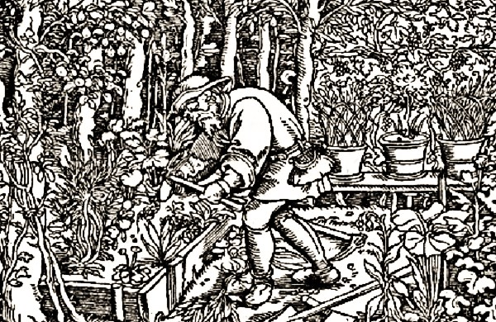
Hybrid vs. Heirloom Seeds
Hybrid Plant Varieties have been artificially cross-pollinated to produce plants that display characteristics of two different plant varieties. Many seed companies advertise their seeds as “Non-GM”. However, it’s unlikely that you can purchase genetically modified seeds as a hobbyist gardener as these seeds are sold only in bulk to commercial farmers. It’s technically possible, but unlikely that hybrid seeds could have been produced by a normal plant that was pollinated by a GM plant. The non –GM label only certifies the seed producer isn’t reselling GM seeds to individuals.
Unlike heirlooms, hybrids are reliable and can be counted on for high yields. They will look more like the vegetables you find in the grocery store and will many of those same characteristics. You can save hybrid seeds but it’s not recommended because you can’t rely on them. Sometimes the seed won’t grow at all, but regardless, you will most likely end up with an inferior plant. It’s best to purchase hybrid seeds each year from the commercial seed producer. Many gardeners like to keep a mix of hybrids and heirlooms in their vegetable garden until they have established what heirlooms grow best in their garden.
Hybrids almost always require more water than heirlooms. Without enough water, they shrivel and die. Heirlooms will produce smaller yields without sufficient water, but except in extreme cases, they won’t entirely die off as will a hybrid.
Heirloom Plant Varieties - So far the experts have agreed that heirlooms are old, open-pollinated plant varieties, but beyond that description, there is some disagreement. Some authorities say heirloom vegetables are those introduced before 1951 while others suggest the 1920’s. Heirloom seeds are more expensive than hybrid seeds. However, you only need to purchase the packet of heirloom seeds once. If you save the seeds each year from your healthiest plants you never have to purchase those seeds again. Heirloom vegetables tend to bruise more easily and can’t be stores for long periods of time, but they are more diverse and flavorful than hybrids.
For further reading, we recommend: A Guide to Seed Saving, Seed Stewardship and Seed Sovereignty by The Seed Ambassadors Project. https://www.adaptiveseeds.com/sites/default/files/pdf/Seed%20Saving%20Zine%204%20handout.pdf
_______________________________________________________________________
LOVING GARLAND GREEN – official stewards of the first Garland Community Garden on City Property in Garland, Texas
Visit our Website at Loving Garland Green.org

